**Background and Scope**

Manitoba Agriculture Weather Program operates and maintains a network of 108 weather stations that provides weather variables such as air temperature, wind speed and direction, humidity, precipitation, solar radiation and soil temperature and moisture at 5, 20, 50 and 100 cm depths.

The program supports many partners and the data has a wide variety of applications such as generating current condition maps, crop thermos-physiological growth stage (e.g. Growing Degree Days, Corn Heat Units etc.) and crop disease risk mapping (e.g. Fusarium Head Blight). The data query process occurs in the database that sits in the managed environment. This job aid provides information required to upload data into the managed environment (ME)

**Procedures**

Three data files are uploaded into the ME every morning: DailyEC.csv, mawp24raw.txt and mawp60raw.txt

**A) *DailyEC.csv***

1. Access the latest file (e.g. yesterday’s DailyEC.csv) from the archive folder: \\MBPApp0964P\Shared_Data\AgWeather\archive and copy into your local desktop.

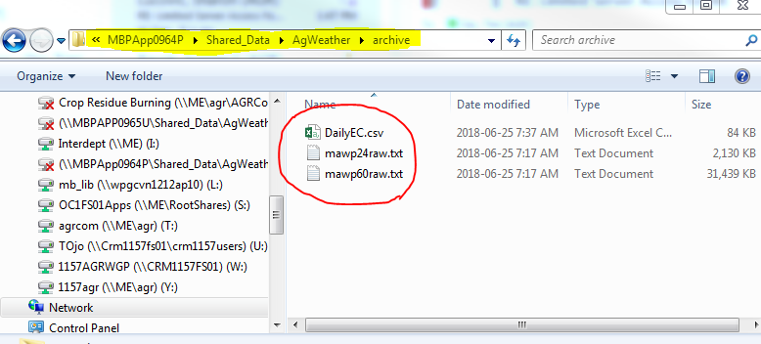

1. Open the .csv file and insert a blank row under the most recent date for each station.
2. Fill the new empty rows with the StaionID and StationName from the rows above it. Write the data using the format YYYY-MM-DD.

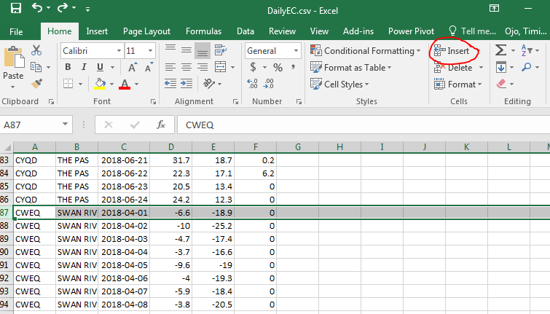

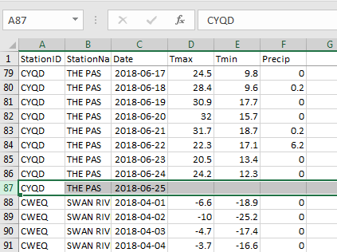

1. To fill the information on yesterday’s Tmax (maximum air temperature), Tmin (minimum air temperature) and Precip (Precipitation); open the Environment Canada’s Frodo Page: <http://www.1144.ca/Summary.aspx?N=MBsu&SID=>. Click the drop-down arrow next to “--- None ---” to select a station from the alphabetically arranged list.
2. Enter the information under the ***Tx*** as Tmax, ***Tn*** as Tmin and ***WG amt*** as the Precip data. If the number of hours indicated under the “Hours” column is less than 22, the row information for that day should not be filled.

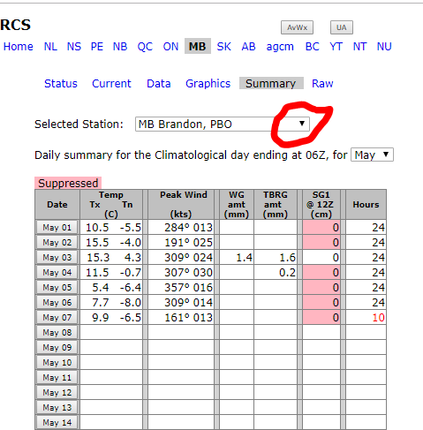

1. Complete this process for all the 24 stations listed in the DailyEC.csv.
2. Save the file (Ctrl + S) and click yes multiple times to close the spreasheet. Do not rename the file.

**B) Daily and Hourly MB Ag Weather Program Data (mawp24raw.txt and mawp60raw.txt)**

1. Go to <https://mbagweather.ca/partners/mbag/>, right click on *mawp24raw.txt* and save link as file on your desktop.

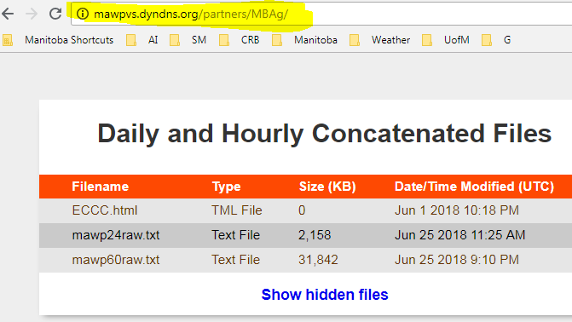

1. Open the text file from the location where it is saved on the computer.
2. Click Edit > Replace (or Ctrl + H). Find *“NAN”* and leave the replace field empty. Click “Replace All”
3. Find *-7999* and *-99* replacing them with nothing.
4. Finally, scroll to the last row of the document and delete the arrow-like symbol and the empty row.

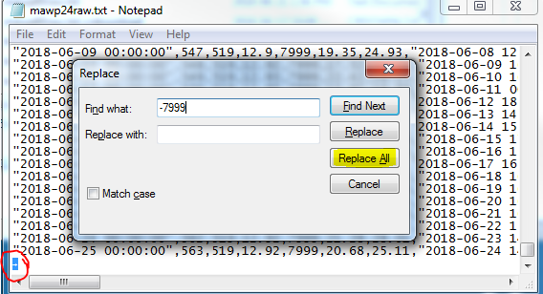

1. Repeat steps 6 – 10 above for the hourly text file (mawp60raw.txt).
2. Copy all three files from the desktop and paste them in the ME \\MBPApp0964P\Shared_Data\AgWeather\upload.

**Note:** The files must be in the ME folder at the top of the hour for the file to be uploaded during the next hourly run. The upload processing takes about 21 minutes and successful upload can be verified by checking that the uploaded data is included in the generated query from the hourly (<https://web43.gov.mb.ca/climate/HourlyReport.aspx>) or daily (<https://web43.gov.mb.ca/climate/DailyReport.aspx>) report.